TripMate User Manual
Travel planning and trip management guide
TripMate helps travellers discover Australian destinations, compare stays, save ideas, and record hotel bookings. Administrators can also maintain the trip catalogue. This guide explains the tasks available in the current application.
Version 1.0 | October 202

Contents
1. Getting started 3
Log in and out 4
2. Find a destination 5
3. View destinations and hotels 6
4. Save destinations and manage bookings 9
5. Share experiences and manage your profile 10
6. Administrator guide 12
7. Troubleshooting and important notes 14

Getting started
Use TripMate in a current desktop or mobile web browser. The traveller site opens on the Explore page. You can browse destinations without an account; create an account to save destinations, book hotels, share experience, and view your profile.
Create an account
- Select Sign up in the top navigation.
- Enter your name, Gmail address, phone number, country, and password.
- Use a password of at least six characters that includes uppercase and lowercase letters and a number.
- Enter the same password in Confirm password, then select Create account.
TripMate validates each field before creating the account. If an email or password does not meet the rules, correct the displayed message and submit again.

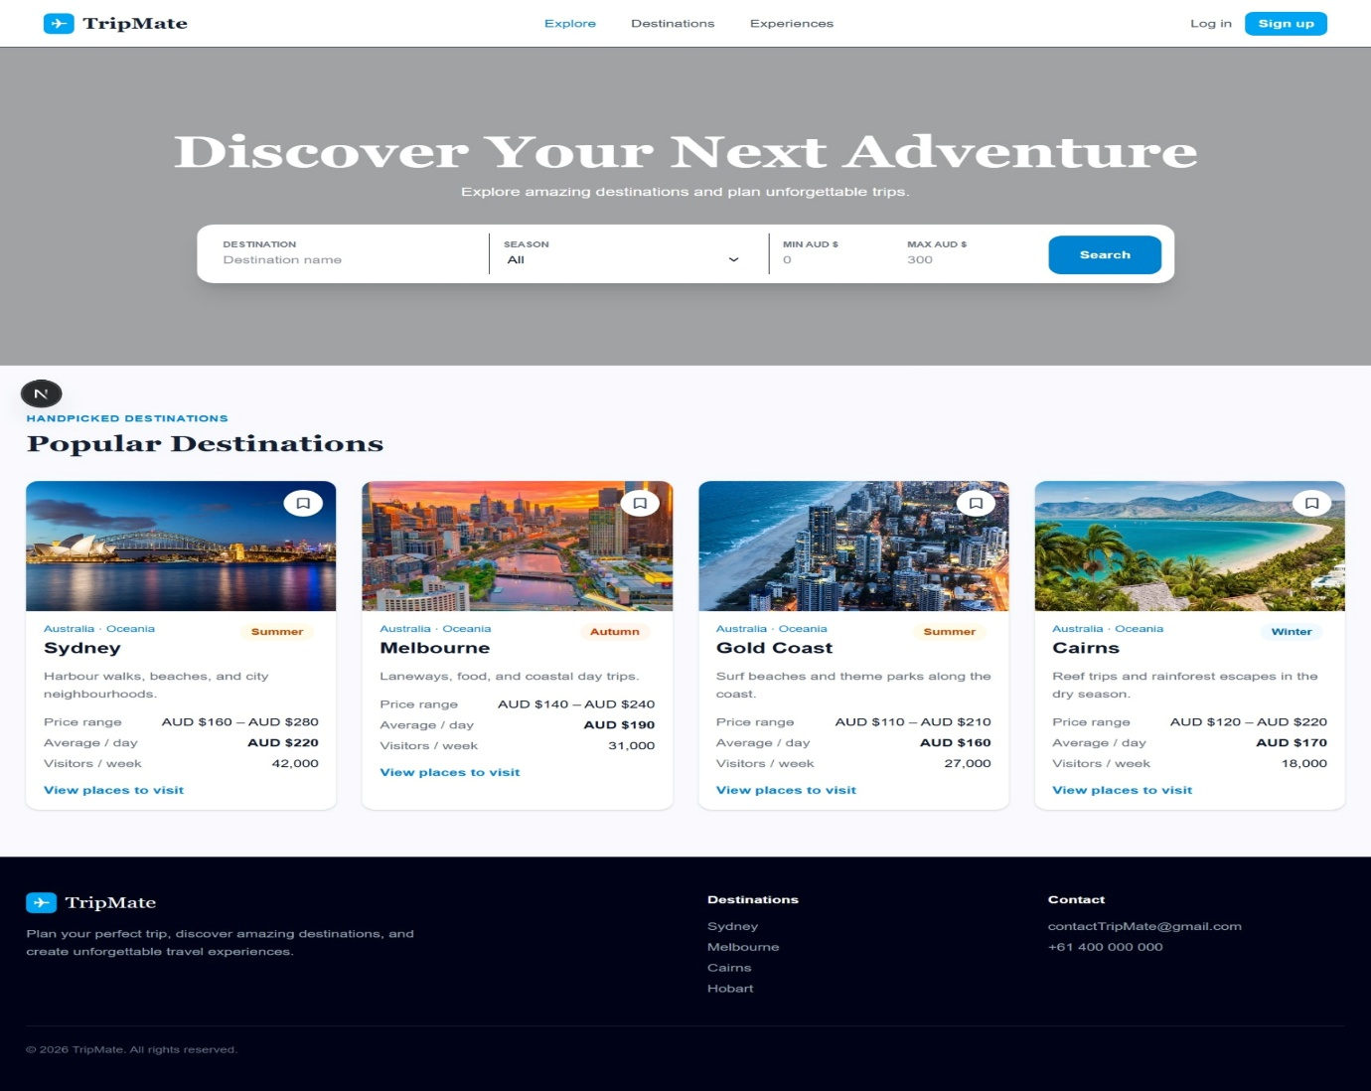
Figure 1.0: Dashboard to ViewDestination

Log in and out
Select Log in, enter your account email and password, then select Log in. Use the profile link in the navigation to open your account page; select Sign out there when you have finished. There is single Login page for user and admin.
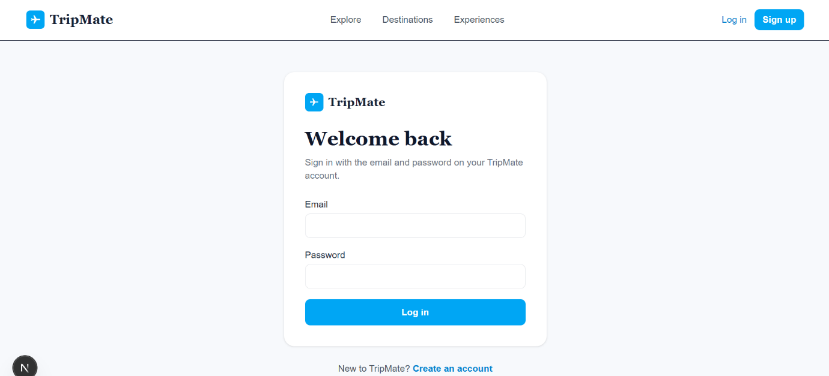
Figure 1.1: Login page
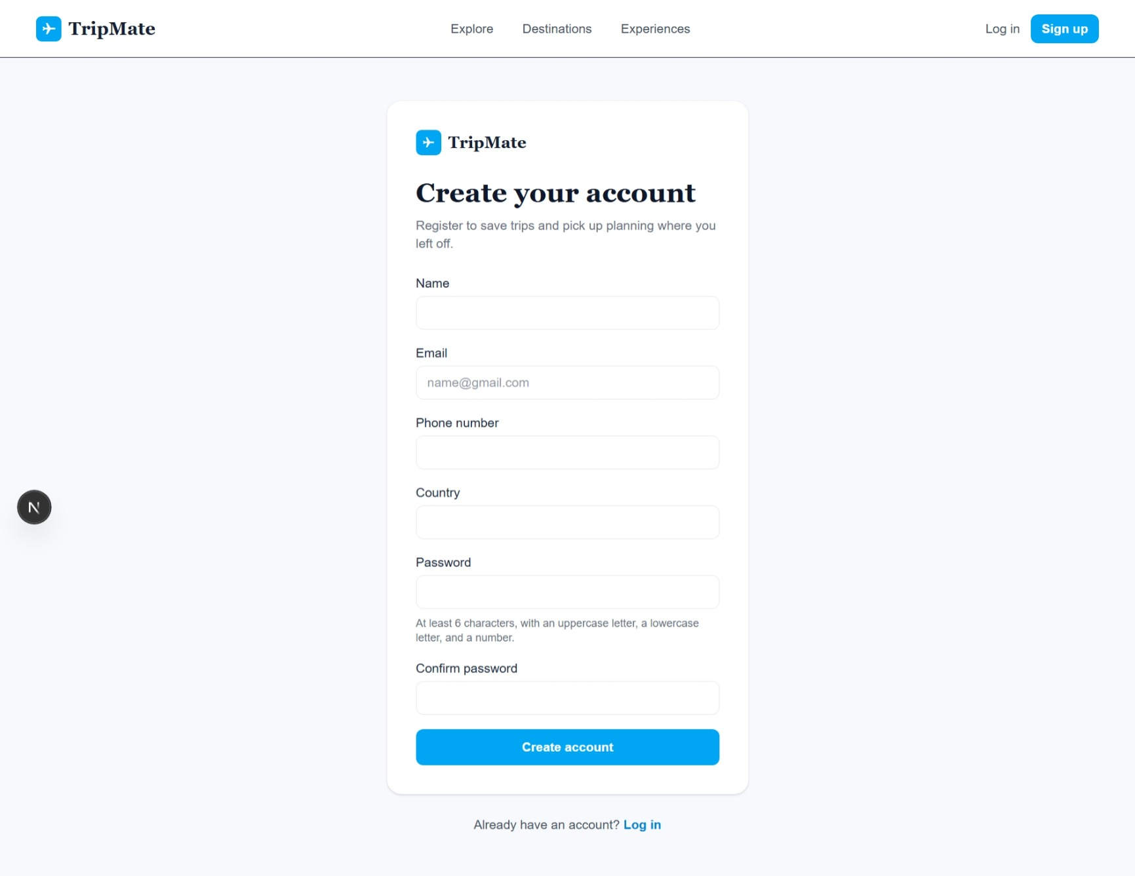
Figure 1.3: SignUp Page

Find a destination
The Explore page provides the quickest way to begin planning. Enter a destination name if you know it, select a preferred season, and optionally set a minimum and maximum daily budget in Australian dollars. Select Search to open the filtered Destinations page. Also you can get more destination in Destination page. Popular destination can be explored in in explore page where all the destination can be found in Destination page. Both pages have searching feature.
Control | How it works
Destination | Matches destination names containing the text you enter.
Season | Choose All, Spring, Summer, Autumn, or Winter.
Min and max price | Shows trips whose daily price range overlaps your budget. The maximum cannot be lower than the minimum.
Sort | On the Destinations page, sort by visitor numbers or average daily price.
You can refine the results at any time using the season buttons, name field, price fields, and sort menu above the destination cards. If no result appears, widen the budget, choose All seasons, or clear the name field.
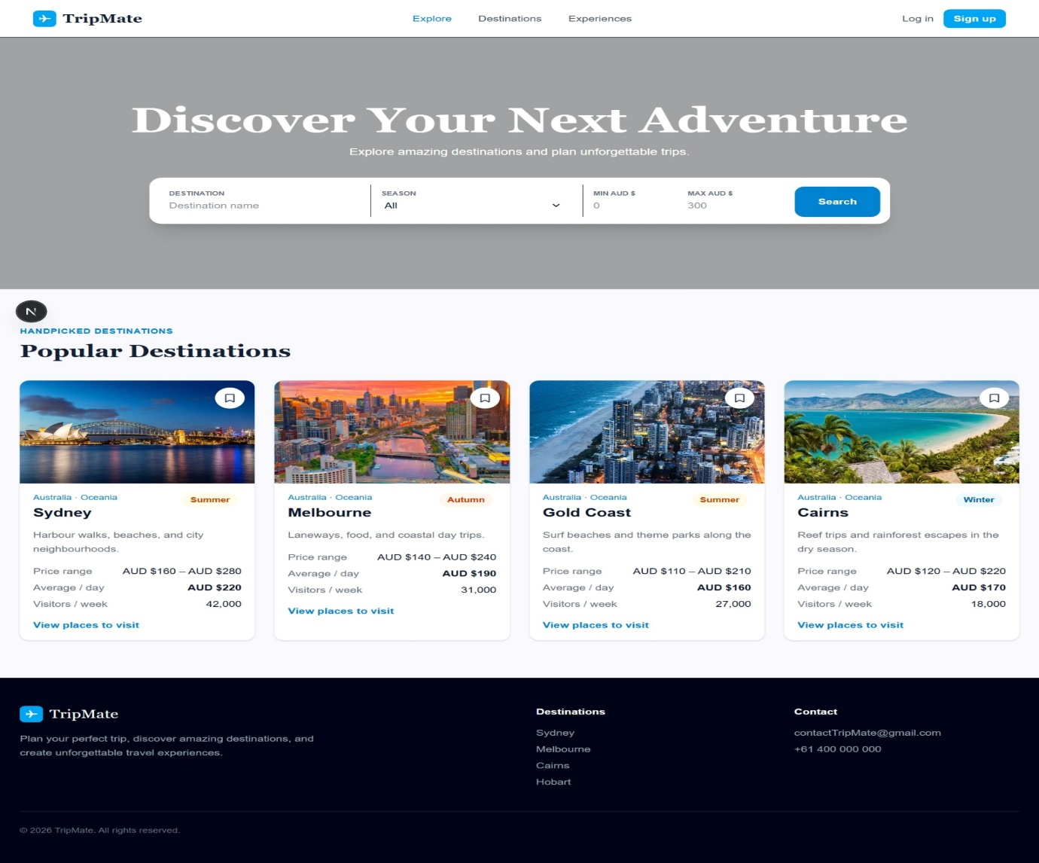
Figure 2.0: Explore Page to view popular destinations
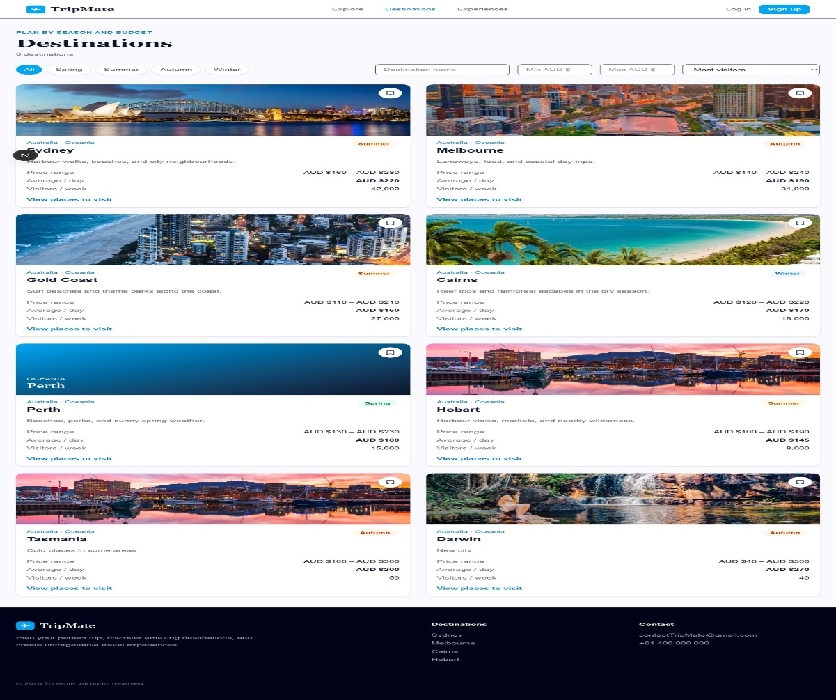
Figure 2.1: Destination Page to view destination page.

View destinations and hotels
Select a destination card to view its detail page. Each page shows the recommended season and trip duration, destination description, daily price range, average daily price, visitor estimate, and suggested places to visit.
Use maps and hotels
- Select Open destination in Google Maps to open the destination in a new browser tab.
- Scroll to Hotels to compare the area, rating where available, description, and nightly price.
- Select View on Google Maps for a hotel location, or select Book to open the booking page.
Book a hotel
- Log in first. If you select Book while signed out, choose Log in in the prompt and return to the hotel.
- Choose a check-in date and a later check-out date. Dates cannot be before today.
- Enter between 1 and 8 guests. The page calculates the number of nights and total before you submit.
- Select Book hotel. A confirmation appears with your stay details and a link to Bookings.
A hotel booking is recorded in the application browser for the signed-in user. It is a planning record; this version does not take payment or issue a supplier reservation reference.
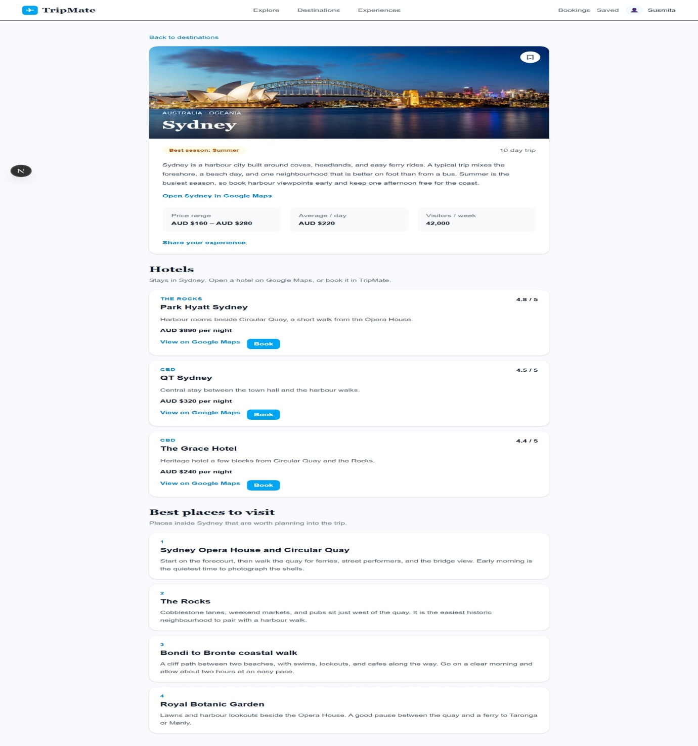
Figure 3.0: full detail page to view detailed destination and hotels
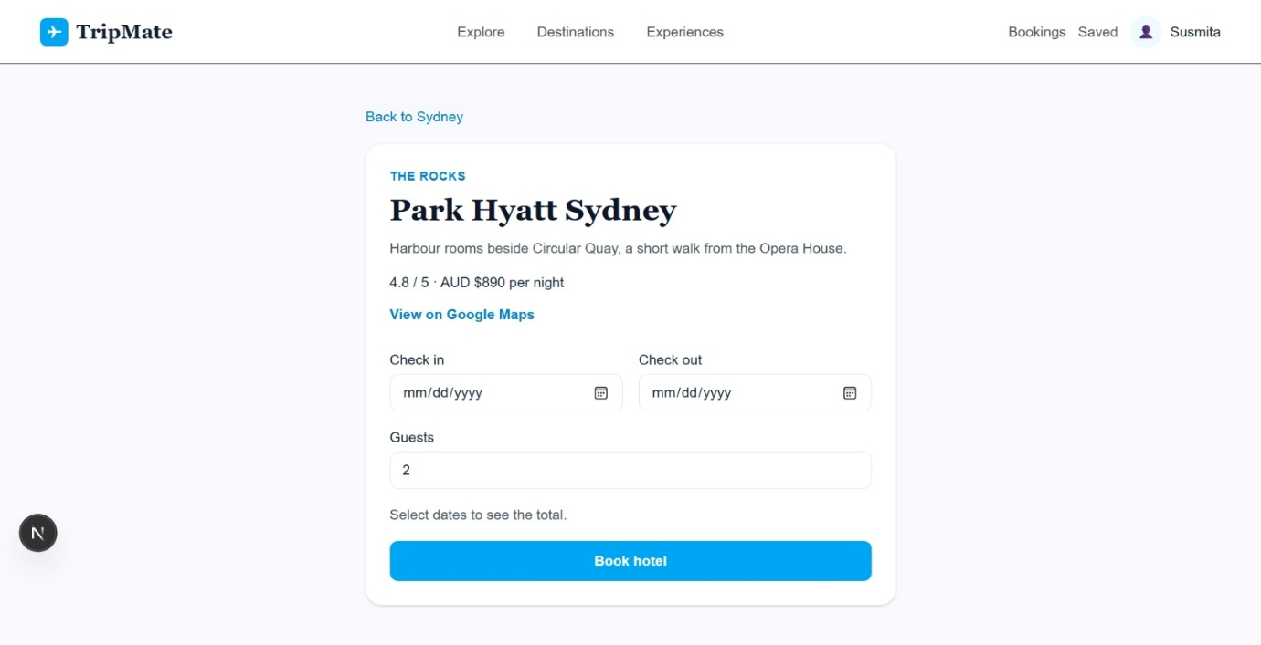
Figure 3.1: Hotel Booking Page
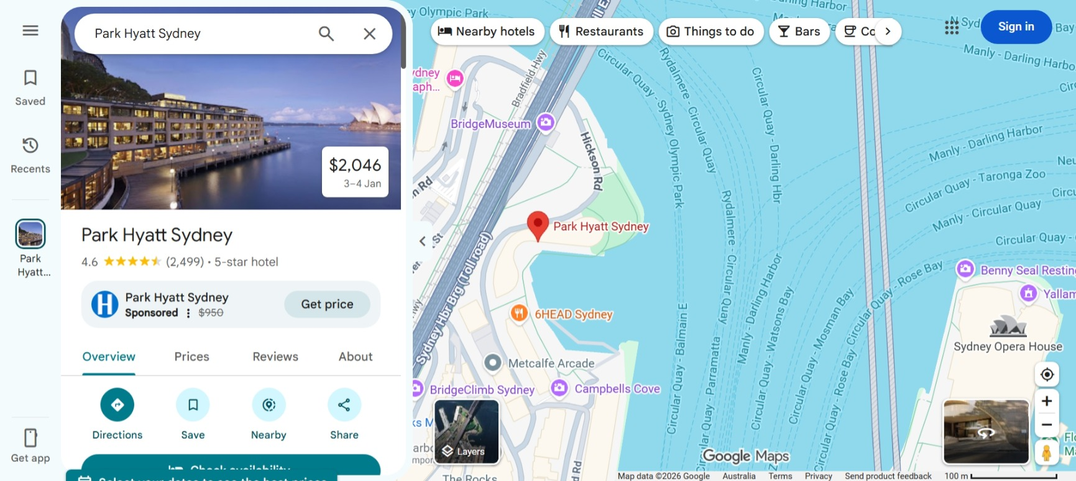
Figure 3.2: View the hotel in maps.

Save destinations and manage bookings
Watchlist
On any destination detail page, select the bookmark button in the upper-right corner to save the destination. The button changes appearance when the destination is saved. Open Saved in the navigation to see all saved destinations or select Remove from watchlist beneath a card to remove one.
Bookings
Select Bookings in the navigation to see your recorded stays. Each entry lists the hotel, destination, dates, guest count, nightly rate, total, and a Google Maps link.
To cancel an eligible booking, select Cancel booking and confirm the action. A booking can be cancelled only when its check-out date is at least three days away. The cancellation removes the stay from your Bookings page.
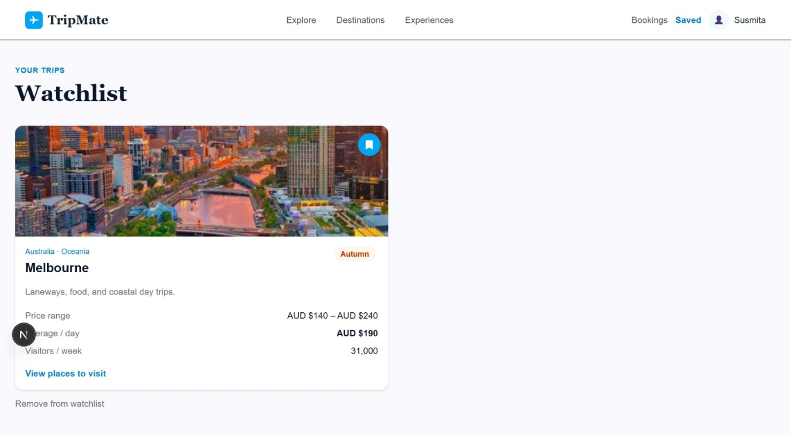
Figure 4.0: Watchlist / Saved Page for the user.
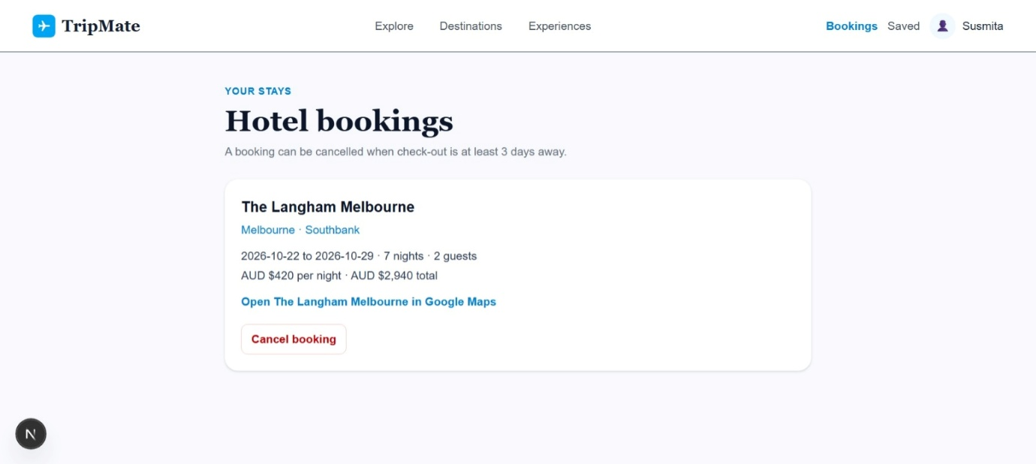
Figure 4.1: Hotel Booking Cancel Page.

Share experiences and manage your profile
Share an experience
- Open Experiences from the navigation or select Share your experience from a destination page.
- Log in if prompted, choose a destination, describe your experience, and select a rating from one to five stars.
- Select Share experience. Your entry appears with other traveller stories.
Use shared experiences as traveller tips and opinions. They do not replace official opening hours, supplier terms, safety advice, or booking confirmations.
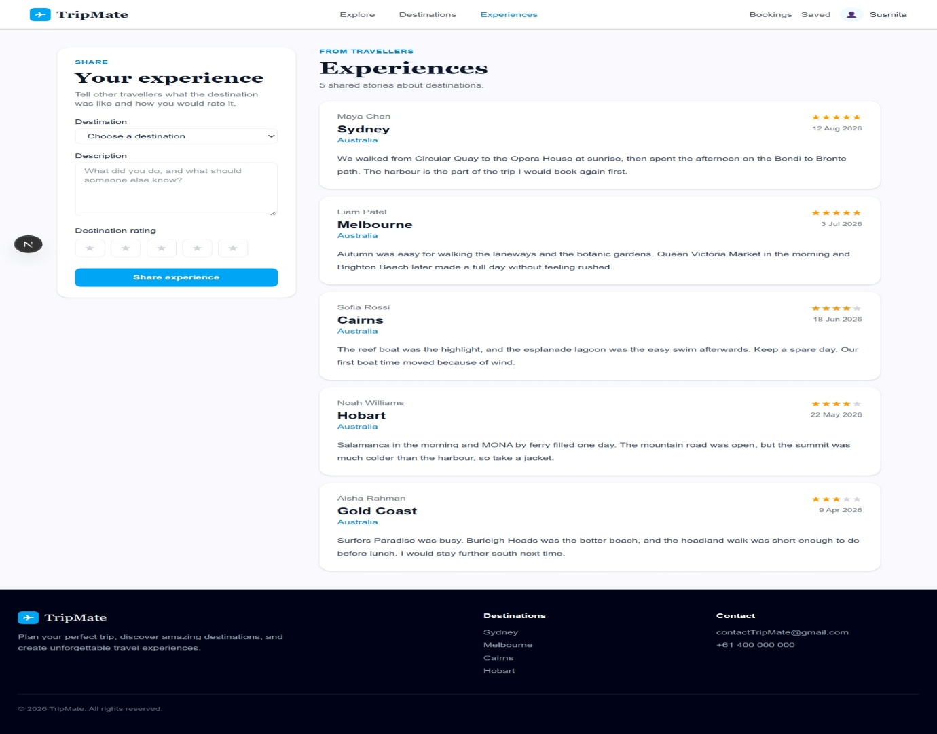
Figure 5.0: View and Share Experience Page.
Profile
Select your name or profile icon in the navigation to view the account name, email, phone number, country, and role. Select Sign out to end the current session.
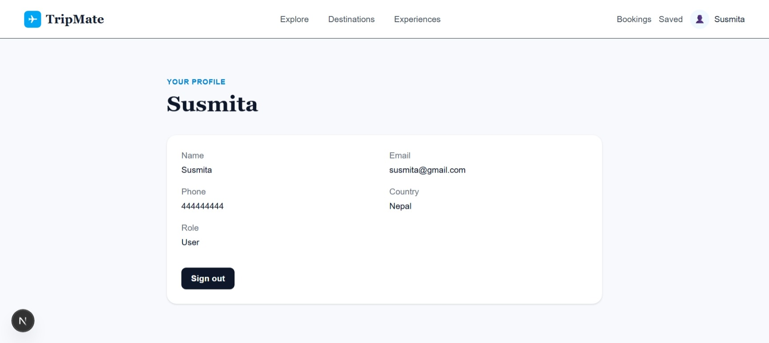
Figure 5.1: Profile Page

Administrator guide
Administrator functions are available only to accounts with the Admin role. Select Admin from the navigation after signing in. The administrator area contains Trips and Add trip.
Add a trip
- Select Add trip, complete the destination information, price range, visitor estimate, recommended days, season, description, and Google Maps place.
- Optionally upload a JPEG, PNG, WEBP, or GIF photo up to 5 MB.
- Use Add hotel to include hotel name, area, nightly price, map search text, and description. Select Remove hotel to discard an unfinished hotel.
- Select Save trip. The new item appears in the catalogue and on the traveler Destinations page.
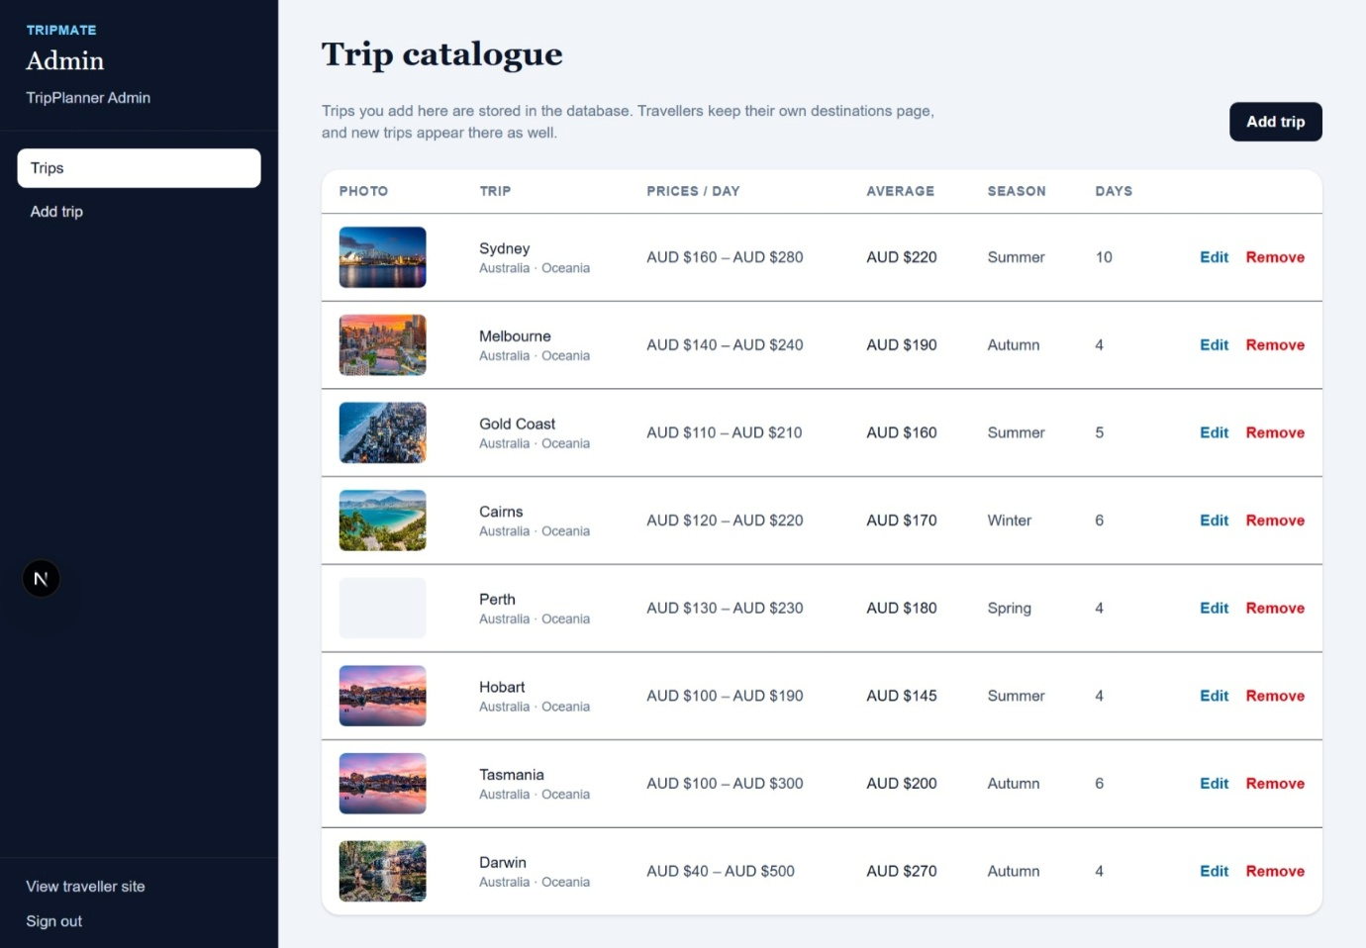
Figure 6.0 : Admin Dashboard
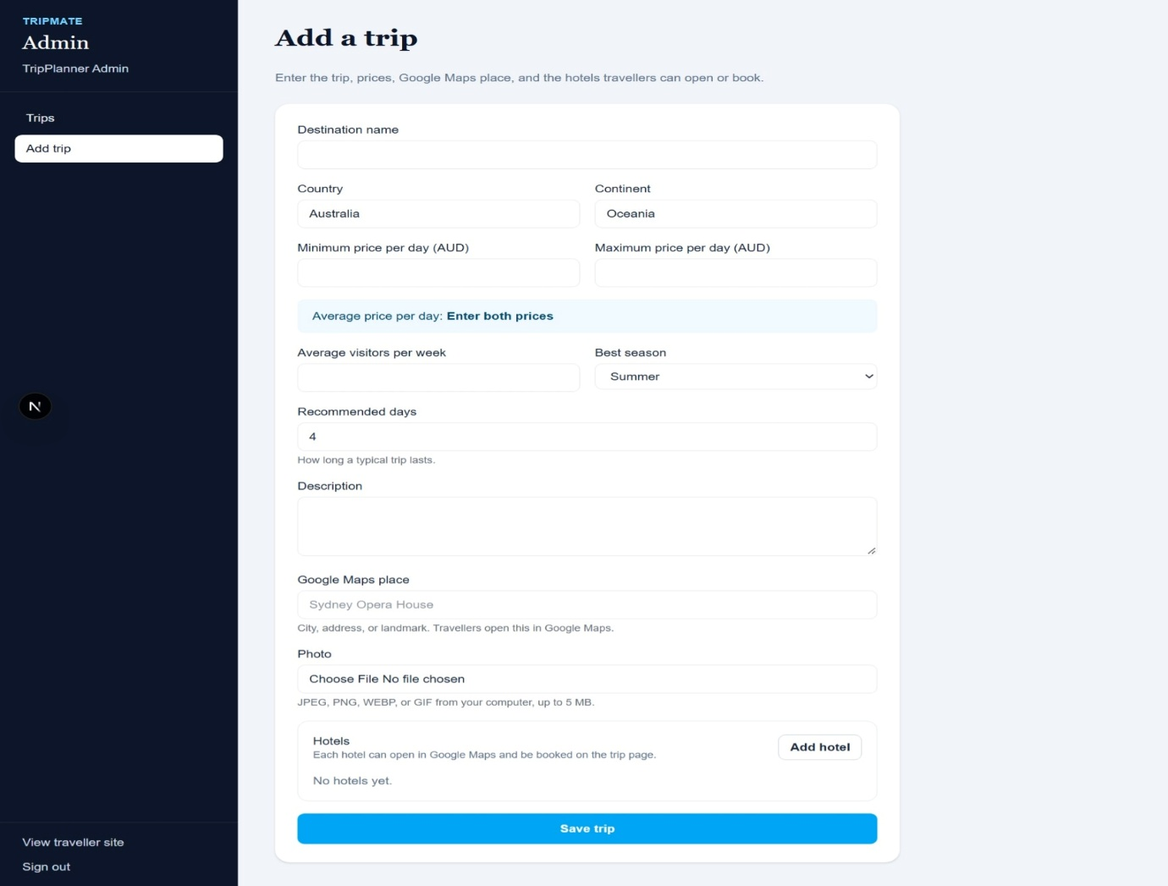
Figure 6.1: Add Trip page for admin.
Edit or remove a trip
In Trips, select Edit beside an item, change the fields, and select Save changes. To delete a trip, select Remove and confirm the browser prompt. Removed trips are no longer available to travelers.
Trip validation requires a destination name, country, continent, valid non-negative price range, whole-number visitor estimate, and one to 365 recommended days. Hotel entries with a name also require a valid non-negative nightly price. You can see the edit remove feature in the admin dashboard in above Figure 6.0 .

Troubleshooting and important notes
Situation | What to do
Cannot log in | Check the email and password, then try again. If the application reports that the session expired, sign in again.
Cannot save, book, or share | These functions require a signed-in account. Use the Log in button in the prompt.
No matching destinations | Clear the destination text, choose All seasons, or widen the daily budget range.
Booking cannot be cancelled | Bookings can only be cancelled when check-out is at least three days away.
Could not reach the server | Confirm that the TripMate API and frontend are running, then refresh the page.
Admin page is unavailable | Only an Admin account can access the trip catalogue and trip editor.
Data and browser storage
Saved destinations, hotel booking records, and shared experiences are stored by the application in the browser. Clearing browser site data, changing browsers, or using another device may remove or hide those records. Destination catalogue and account information use the application service when it is available.
For technical setup or access issues, contact the TripMate project team.

